Ex. No: 3 SQL DCL and TCL COMMANDS

**Date: 01/02/22**

**AIM:** To write SQL queries to execute different DCL and TCL commands.

Data base created for this exercise is:

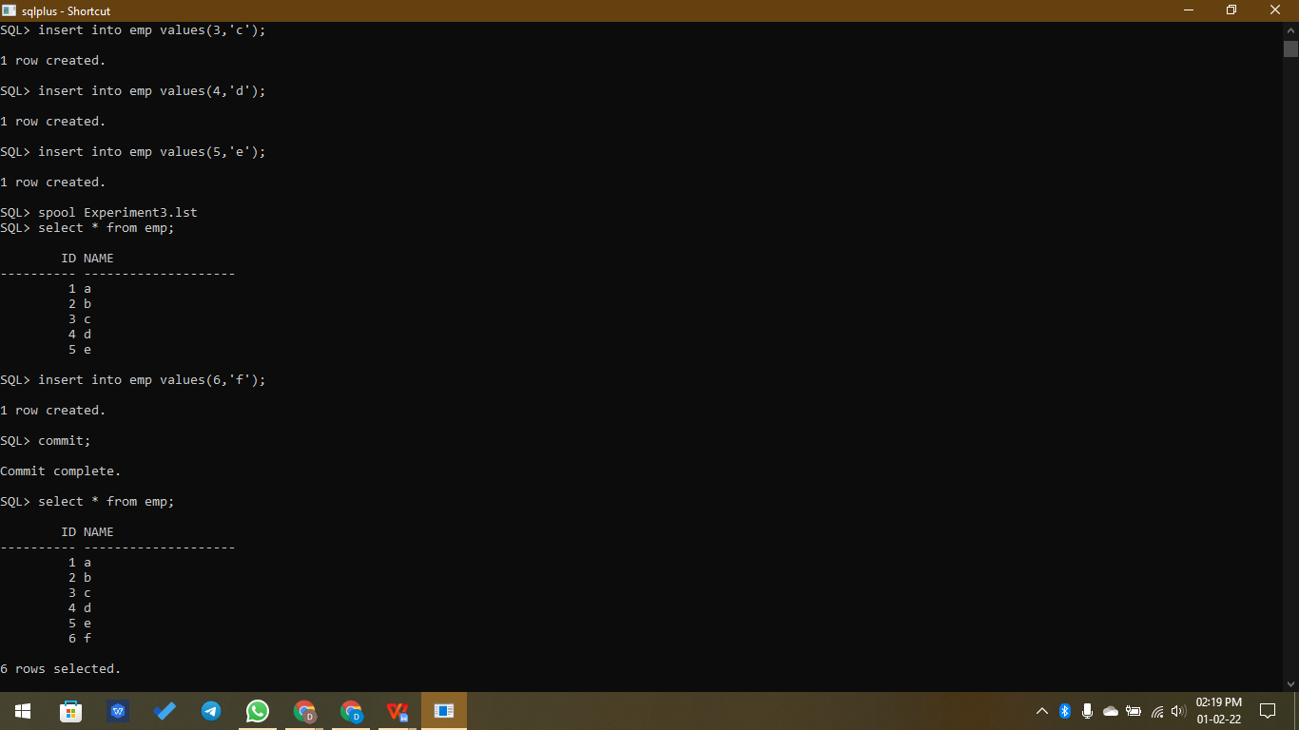

**DCL Commands:**

* **Grant -** Used to give certain permissions for the table (and other objects) for specified groups/users of a database.

**Syntax,**

**GRANT filed_names on table_name to user_name;**

* **Revoke-** Used to take away permissions from groups/users.

**Syntax,**

**REVOKE field_name on table_name to user_name;**

* **Deny -** Used to ban certain permissions from groups/users.

**Syntax,**

**DENY field_name on table_name to user_name;**

**TCL Commands:**

* **Commit -** Used to permanently save any transaction into the database.

**Syntax,**

**COMMIT;**

Example,

SQL> commit;

Commit complete.

* **Savepoint -** Used to temporarily save a transaction so that you can rollback to that point whenever required.

**Syntax,**

**SAVEPOINT savepoint_name;**

Example,

SQL> savepoint A;

Savepoint created.

* **Rollback -** Used to restores the database to last committed state.

**Syntax,**

**ROLLBACK to savepoint_name;**

Example,

SQL> rollback to B;

Rollback complete.

SQL> select * from emp;

ID NAME

---------- --------------------

1 a

2 b

3 c

4 d

5 e

SQL> insert into emp values(6,'f');

1 row created.

SQL> commit;

Commit complete.

SQL> select * from emp;

ID NAME

---------- --------------------

1 a

2 b

3 c

4 d

5 e

6 f

6 rows selected.

SQL> update emp set name='x' where id=3;

1 row updated.

SQL> savepoint A;

Savepoint created.

SQL> insert into emp values(7,'g');

1 row created.

SQL> savepoint B;

Savepoint created.

SQL> select * from emp;

ID NAME

---------- --------------------

1 a

2 b

3 x

4 d

5 e

6 f

7 g

7 rows selected.

SQL> rollback to B;

Rollback complete.

SQL> select * from emp;

ID NAME

---------- --------------------

1 a

2 b

3 x

4 d

5 e

6 f

7 g

7 rows selected.

SQL> rollback to A;

Rollback complete.

SQL> select * from emp;

ID NAME

---------- --------------------

1 a

2 b

3 x

4 d

5 e

6 f

6 rows selected.

SQL> spool off

**Result:**

Thus the DCL and TCL commands are used to modify or manipulate data records present in the customer database tables.